**The chance of a lifetime!**

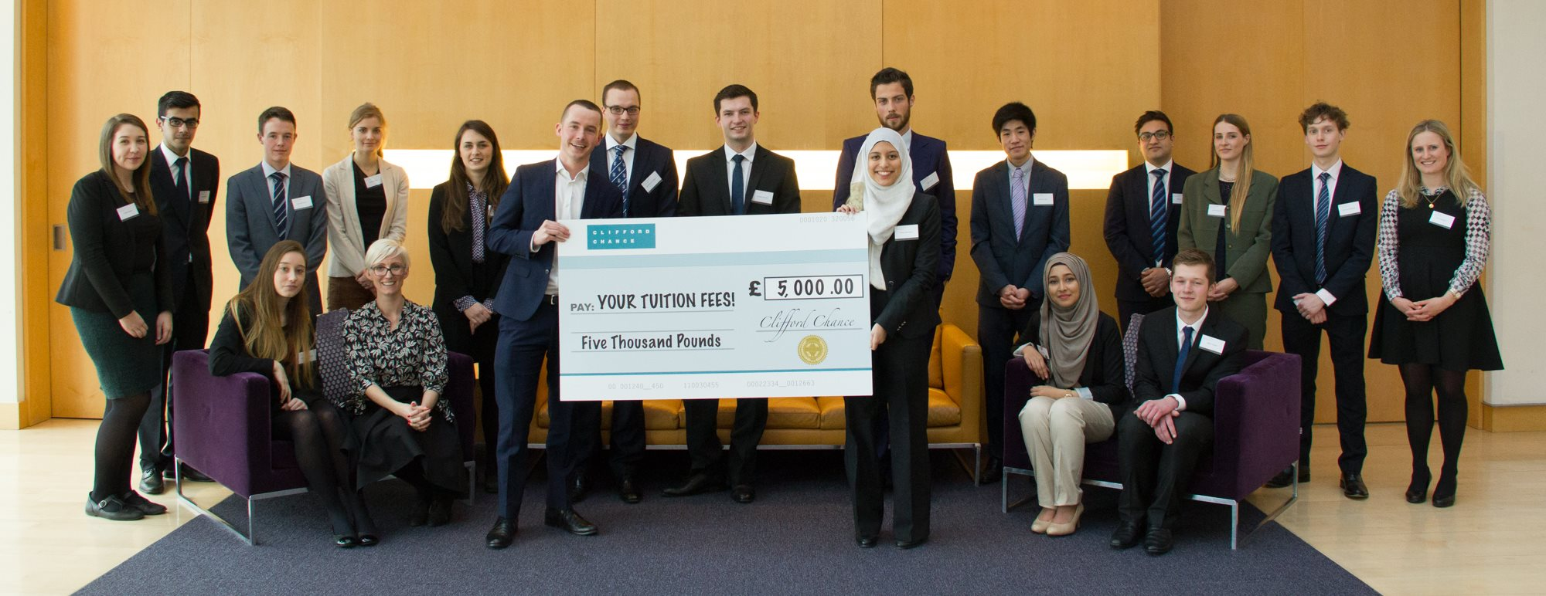

**Info:**

Now in its fifth year, Intelligent Aid is a unique essay based competition which invites students from all backgrounds and disciplines to bypass the traditional route of online applications and assessment days, to win valuable experience with the prestigious firm.

Intelligent Aid is the competition that asks big questions about the modern world – and your answer could get your commercial law career off to a flying start. Clifford Chance is offering you the unique opportunity to bypass the traditional route of online applications and assessment days, to win a place on their prestigious vacation scheme.

To enter, all you have to do is write a 600-word essay answer to the above question and then submit it via the firm’s website before **21st February 2016**.

The challenge is open to **all undergraduates and post graduates students**, irrespective of the degree subject that you are studying. What’s most important is your display of intellect, creativity and understanding of the topic – and your ability to write with impact!

**The prize:**

**The 40 best entrants will be invited to attend the final taking place on 13th and 14th April 2016. The top 20 entrants will win a place on the vacation scheme – bypassing the standard application process with the sheer quality of their thinking. The overall winner will be awarded £5,000 towards their University fees.**

**The Big Question**

**Ethics in Business: Ethical business culture can only be created by strong regulation. Discuss with reference to one or more industry sectors. (600 words max.)**

The concept of business ethics applies to all aspects of business conduct and is relevant to the conduct of individuals and entire organisations. In the wake of the financial crisis, culture and ethics have emerged as key themes for regulators, enforcement authorities and courts as they seek to promote systemic change. Senior individuals are increasingly held to account and the calls for criminalisation of both institutions and individuals spreading around the globe.

You could approach the question from a number of different perspectives, whether your interests lie in history, economics, current affairs or legal theory. This challenge demands the kind of enthusiasm, curiosity and intellectual edge that’ll make you successful as a lawyer with Clifford Chance.

Whatever approach you choose to take, this topic is one that has been at the heart of much controversy and debate and Clifford Chance are very much looking forward to reading your submission!

Profile from a student:

“Participating in the Intelligent Aid competition was an immensely enriching experience. The competition involved writing a response to the question, ‘The Rule of Law is essential in ensuring an economy’s success?’ I decided to apply because I looked forward to the challenge of writing a response to an interesting, thought-provoking and topical question. Additionally, the ability to develop and demonstrate my commercial awareness throughout the process appealed greatly to me. I attended the Intelligent Aid workshop organized by MyKindaCrowd and was left inspired. The workshop involved a discussion and presentation on essay-writing tips such as identifying the scope, defining key terms and thinking creatively. I made a note of these pointers, put them into practice and submitted my essay after researching extensively and writing many drafts.

I was delighted when I received an email invite to the Finals, a 2-day event held at the Canary Wharf offices. 20 participants were awarded a vacation scheme following success at the assessment at this stage. There were group activities and several presentations about public speaking techniques, Clifford Chance’s various departments and the work the firm was involved in. We were then treated to a dinner with the Graduate Recruitment team and partners that night. The hardworking and passionate individuals I met at the firm thoroughly impressed me. They were approachable and willing to answer all of our questions.

The assessment on the second day was challenging as I had to think quickly and deeply on the issues I had presented earlier. I enjoyed this experience and it felt surreal when I was eventually declared the overall winner and awarded £5000 towards my university fees! I had learnt so much from the process and winning it was an incredible bonus. I cannot wait for my vacation scheme in the summer to begin! I highly recommend Intelligent Aid to any aspiring solicitor looking for a challenge and the chance to impress, as it is a wonderful opportunity.”